**CSE211 Web Programming, Fall Semester 24/25**

**Assignment #1: Websites conceptual Design and mock-up**

**Raghad Mohammed Radwan 222100569**

**Core idea of the assignemt**

it's to understand the evolution if web and apply that knowledge to plan design and build

Our own website. This involves researching web evolution from the preliminary stages till now. Then plan our website from zero starting from the groundwork and deciding what the purpose and the audience and so om and after the plan is clear we start designing the website including multiple design apps and principles like gestalt, overall it's the steps of creating a website starting from the fundamental website planning concept till designing the website and adding the html and so on.

CSE211 Web Programming, Fall Semester 24/25

## Research

**The defining characteristics of Web 2.0 to We 4.0**

The invention of Hypertext Markup Language (HTML) led to the development of the World Wide Web. It developed from web 1.0 to 4.0 going through different phases and developing in different aspects. And each had a defining characteristic.

**Web 2.0** **defining characteristics**: introduced social features and user-generated content, it was a participatory web where users could tag and engage directly with the content. Like Facebook in terms of socializing, commenting and tagging, or YouTube in terms of user experience and Wikipedia in terms of user participation and so on. It basically allowed users to easily create and share content and engage with it directly .

**Web 3.0 defining characteristics:** which is called the Semantic Web, is about making data more meaningful; Because linking data is the power of web 3.0. it emphzise personal data ownership through the use of blockchain which interpret and connect data more effectively, allowing smarter , more personalized web experiences, also enable seamless web navigation

**Web 4.0 defining characteristics:** (symbiotic web) it directly connects users to the machine by going through advanced AI and brain-computer interface which enable seamless web navigation enhanced decentralization, security, and personalization.

1. **what are the key features of Web 2.0 and how it empowers the power of networks?**

highlights user-generated content, ease of use, participatory culture, and interoperability. This version of the web really unlocked the "power of networks" by allowing users to interact, connect, and build communities online. By giving people the tools to create and share content easily, Web 2.0 created a more collaborative and interactive experience. This made the web much more than just a place to find information – it became a place where users could connect and create their own experiences. This is where services like Facebook, Twitter, and YouTube come in; they allow users to shape the web by actively contributing to it.

1. **what are the key features of Web 3.0 and how it empowers the meaning of data and knowledge connections?**

Key features of Web 3.0 include using semantics to interpret data, decentralizing data so users have ownership, and blockchain technology for secure, decentralized transactions. Edge computing also helps by making data more accessible on local devices, which is important as Web 3.0 pushes processing power closer to users

1. **what are the key features of Web 4 and h0w it empowers the intelligence connections?**

Key features of Web 4.0 include brain-computer interfaces that let users control devices just by thinking, **AI** that can recognize what users are looking at or saying, and **IoT** which connects all sorts of devices to make information sharing smoother. There’s also a focus on personalization and privacy, giving users control over their data.

With these tools, Web 4.0 strengthens "intelligence connections" by making the internet a more interactive, smart, and intuitive space.

1. **The importance of collective intelligence, social networking, social media and social bookmarking**

Collective intelligence, social networking, social media, and social bookmarking have become really important because they allow people to connect and share information easily. Collective intelligence is like the combined knowledge we get when people work together. Social networking sites let us build relationships and communicate directly, which makes sharing ideas more natural. Social media helps spread messages widely, letting people engage and interact with content. Social bookmarking makes it easier to organize and share valuable resources with others, so people can find useful information and build on it.

Together, these tools help increase knowledge and creativity by bringing people’s ideas together and making it easy to collaborate, which is really valuable for learning and innovation.

1. **How these technologies empower the current and future business plans**.

These technologies – collective intelligence, social networking, social media, and social bookmarking – are really powerful for business growth now and in the future. They help companies connect with customers and understand their needs better, which means they can improve their products to match what people want. Social media and networking platforms allow businesses to interact directly with customers, get feedback, and create a strong brand presence online. Social bookmarking helps businesses organize content that interests their audience, keeping people engaged.

Overall, these tools help businesses build customer loyalty and stay flexible, which is essential as markets change. By using these tools, companies can plan for long-term growth and adapt to what their customers need

1. **How do you intend to use the latest technologies in your profession?**

In my career, I plan to use the latest technologies to work more efficiently and stay connected with developments in my field. I’d like to use collective intelligence tools for teamwork because it makes it easier to collaborate and combine everyone’s ideas. Social media and networking will help me build connections with other professionals and stay current with trends, which is really useful for personal branding and career growth. Social bookmarking is also great because it lets me save and organize helpful resources, so I can easily refer back to them.

These technologies will help me work smarter, keep my skills relevant, and stay on top of new developments, all of which are key to growing in my profession.

**Website planning**

**Define the purpose of your intended website**

This website aims to provide users with a smart, easy, fun, and personalized way to organize their closet and get outfit inspiration right from their own wardrobe according to their wants and needs. By organizing their clothes into categories, users can easily keep track of what they own and create new looks without confusion or frustration. The website offers customized styling ideas based on categories, events, or specific vibes the user has in mind the idea is simple: take photos of your clothes, sort them into categories (like jeans, skirts, jackets) and let the app help you pick the perfect fit. With everything in one place, the site becomes your go-to for outfit ideas that suits your vibe.

1. **. What would you like the website to accomplish?**

- Help users organize user’s wardrobe digitally, making it easy to manage clothing items.

- Provide personalized outfit suggestions based on user preferences, styles, and occasions.

- make user’s less frustrated by the common saying “I have nothing to wear”

- Enhance user engagement through social features like polls and likes, creating a community around fashion choices.

- make people who feel like they can’t keep up with the fashion trends either because they seem complicated or too much to achieve the look, they want with what they have

1. **. Who is your intended audience?**

* both genders male and female.

- Age would approximant vary from 12 y/o to 55 y/o (not exact)

- Fashion interested people looking for inspiration

- young adults wanting to optimize their wardrobe while keeping up with the fashion .

- User’s interested in maximizing their clothing usage.

1. **. What opportunities, problems, or issues does your planned website address?**

The website addresses several issues:

Difficulty in deciding what to wear or how to wear specific clothes according to fashion

The hassle of remembering all the wardrobe items and their fits

People who struggle to style their clothes or want to imitate a certain style but can’t

Opportunities

-Wardrobe management easily without worry

- no need to feel stressed or worried about how to style or what to wear to a certain occasion

- encourage users to maximize the use of their existing clothes, the site promotes different fashion choices without costing much money or effort

1. **. What kind of content could be incorporated on your website?**

Content ideas include:

- User-uploaded photos and descriptions of clothing items.

- Outfit inspiration galleries curated from user submissions or trending styles.

- Style guides and tips for different occasions.

- User polls and feedback on outfit choices.

User profiles with options to save favorite outfits, recent uploads, and styling suggestions

1. **. How will the site serve the client?**

- Providing a user-friendly interface for wardrobe management.

- Using AI to generate personalized outfit suggestions quickly.

effortless outfit planning

- Facilitating social interactions that help users make style decisions.

- Offering insights into their wardrobe usage and preferences over time.

1. **What's the best method for the user to do what's wanted?**

- A simple upload process for adding clothing items to their wardrobe.

- easy navigation for browsing through categories and outfit suggestions.

- Clear prompts for users to input their preferences (e.g., occasion, desired style).

- Easy access to social features like polls and likes.

1. **. How will users find the function?**

Users can discover functions through:

- A well-structured menu and interface that guides them to upload clothes, view suggestions, and engage socially. By clicking on the desired thing, they want whether it creating specific outfits or adding clothes to their wardrobe.

1. **How will the results of the function be received?**

Outfit suggestions will be presented as styled images or visual collages in the user’s feed when asked. Users can save, like, or request more options based on these initial recommendations.

1. **What will the receiver do with the received entries?**

Users can view, save, or adjust generated outfits. They could also initiate a poll if they want feedback on certain looks or randomize options for additional styling

1. **. How will the receiver deal with results?**

Users will build a collection of preferred looks, saving specific outfits or requesting new options. Creating their own outfits and saving it for the future. They might also use interactive features, such as sharing outfit options with friends or voting on other users’ polls.

1. **What follow-up will be needed?**

Notifications when new outfits or seasonal styling ideas become available.

Reminders for users to add new items as they update their wardrobe.

Engagement through periodic polls, allowing users to re-engage with the community

Suggesting a specific item to buy to complete certain desired looks by notifications or in app suggestions

1. **List at least two related or similar sites found on the Web. Explain why you chose them.**
2. Whering - https://whering.co.uk/
3. Openwardrobe - https://www.openwardrobe.co/

They were one of the best applied websites/apps of this idea whether from style, content or design aspects

### **Planning analysis sheet.**

1. **Website goal:**

“PickAfit” website is all about giving people an easy, fun way to organize their closet and get outfit inspiration right from their own wardrobe. The idea is simple: take photos of your clothes, sort them into categories (like jeans, skirts, jackets), and let AI handle the details so you don’t have to type everything out. With everything in one place, the site becomes your go-to for outfit ideas tailored to your vibe. Whether you’re looking for a sporty look, something dressy, or even a mix-and-match combo, the AI pulls from your own clothes and suggests fits based on styles you actually like. You can even describe where you’re headed or what mood you’re in, and the app will suggest outfits inspired by looks from all over the net

1. **Page titles:**
2. Wardrobe page
3. Outfits page
4. Settings page
5. Sign in page
6. Get App page
7. Privacy policy page
8. Terms of use page
9. Sign up page
10. **Contents:**

**Homepage contents :**

Images of every specified category

Text for the bar

Logo

text

**Wardrobe page contents:**

Images of every specified category

Text for the bar

logo

text

**Outfits page contents:**

Images of every specified category

Text for the bar

logo

text

**Settings page contents:**

Texts

Separate boxes for each category of the account

Logo

**Sign in page:**

Texts

Separate boxes for each category of the account

Logo

**Get app page:**

Texts

Separate boxes for each category of the account

Logo

QR code

Pop page for the app

**Sign up contents:**

Texts

Separate boxes for each category of the account

Logo

Sign-up pop-up page

**Privacy policy page content:**

Text box of all the privacy policy

background

**terms of use page content:**

Text box of all the privacy policy

Background

1. **How will users use forms to collect information?**

There’s multiple way for users to collect information. For example, they could register/make an account which will save their data, they’ll be able to do a survey via email for any suggestions or complains. The poll feature would help people sharing their opinion by when a user shares a poll to the app between two outfits the app will send a notification to other users to vote if they want to help each other.

1. 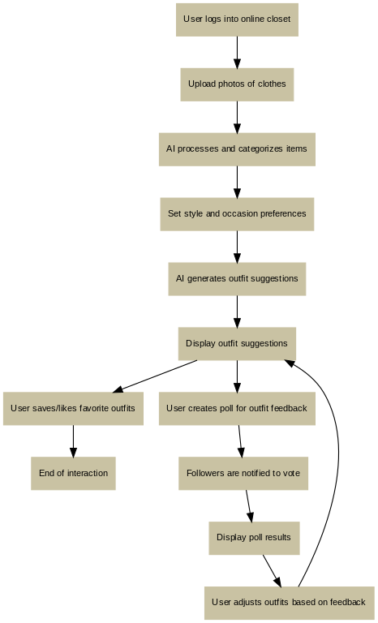**Flowchart**
2. **Pages wireframe**

**Home page**

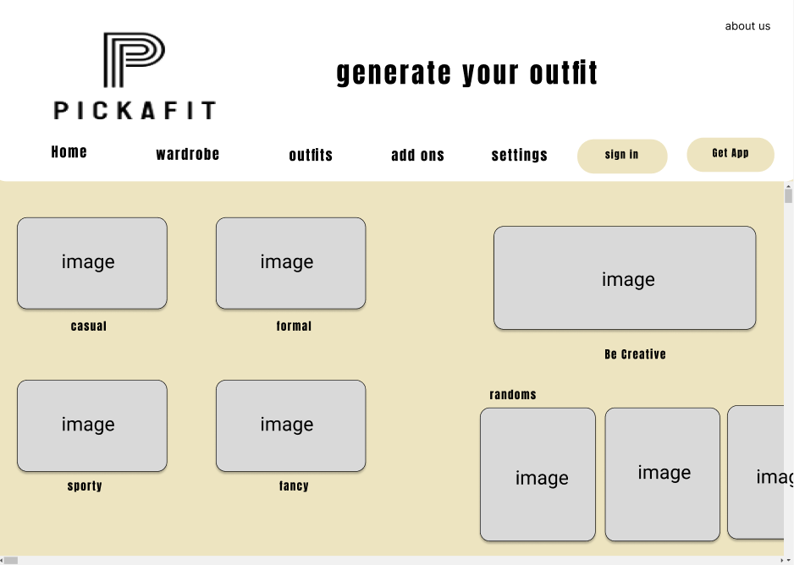

**Wardrobe page**

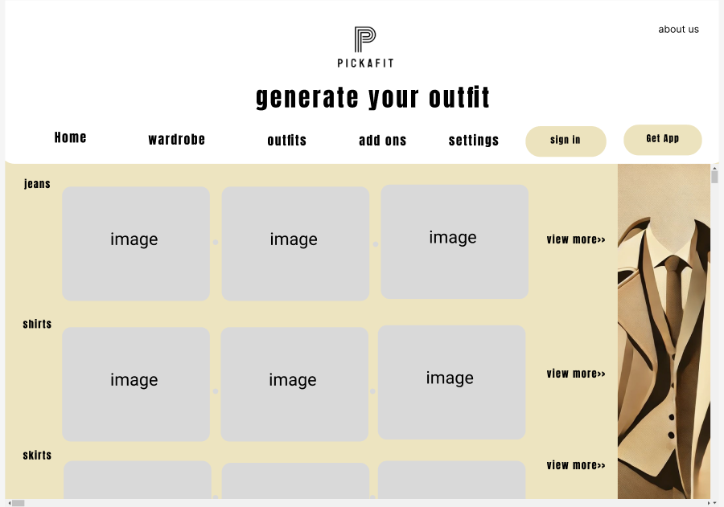

**Outfits page**

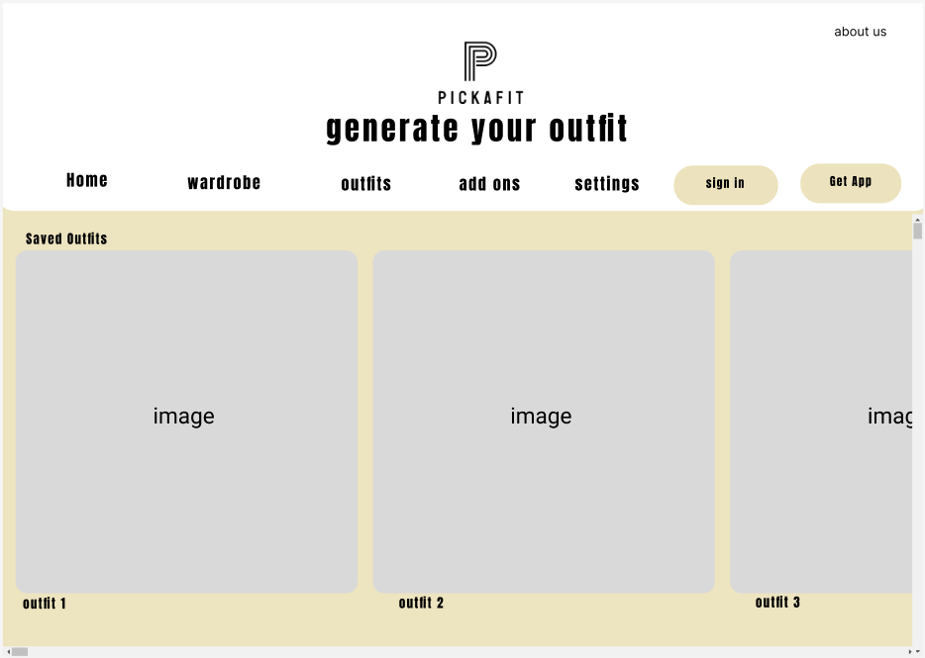

**Settings page**

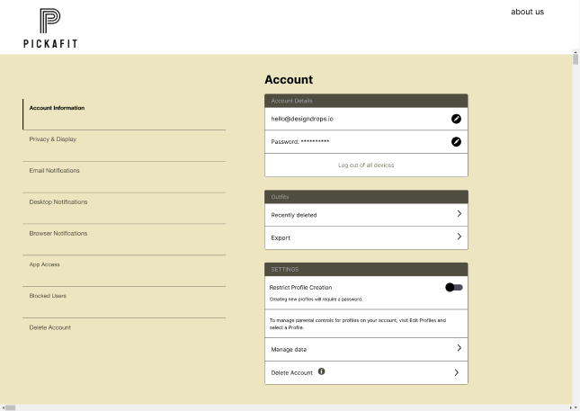

**Sign in page**

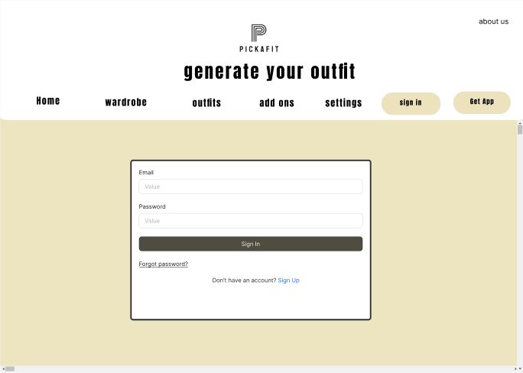

**Get app page**

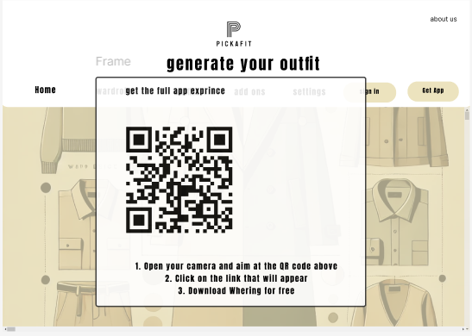

**Sign up page**

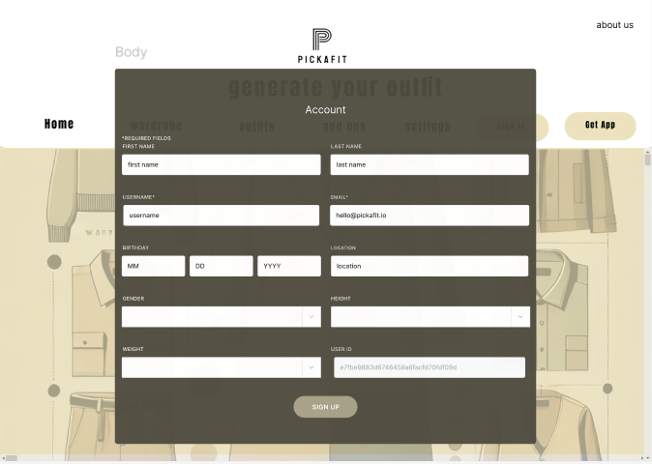

**Privacy policy page**

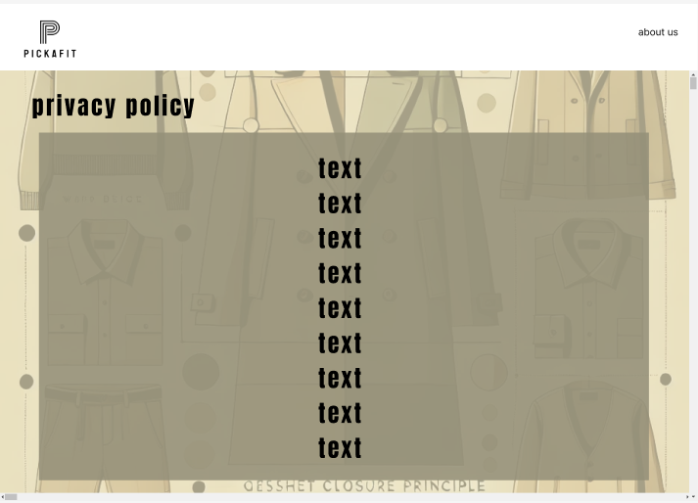

**Terms of use page**

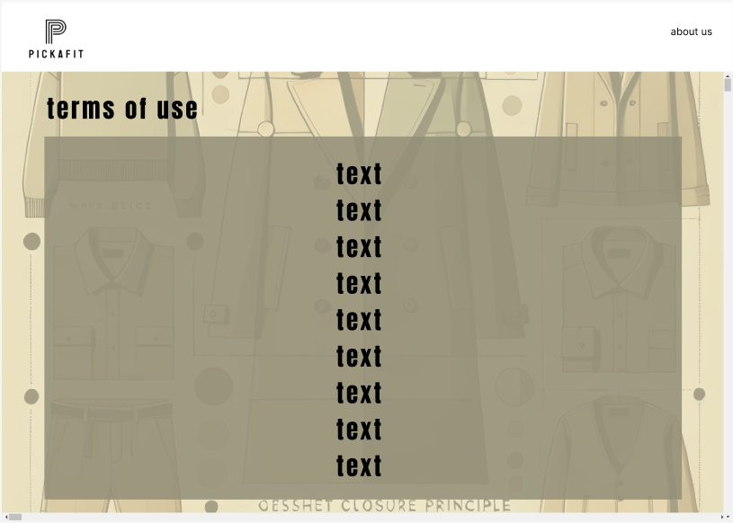

**Website design**

**[A]**

1. **Law of PRAGNANZ**

It’s about simplicity order, and clarity in all the web pages has same shapes which are rectangular but in different sizes and ordered in a way that’s simple and easy to understand and see also the colors are

1. **Symmetry and order**

The shapes are the same which is easier for the eye to follow the whole website follow this principle

1. **Uniform connectedness**

The little circles between the squares in the wardrobe page connects them

1. **Common region**

for example, the settings page where the account shows every category is enclosed in a separate rectangular so everything inside is related

also, the proximity is used in the site a lot

1. **Continuation**

Each c category is in a separate line continuing to the right till you press view more

1. **Parallelism**

Most of the site elements are parallel to each other which shows relation and order

1. **Similarity**

Is used a lot either in shapes or content for example jeans together similar cause they are one element and so on

**[B]**

1. Screen resolution : 1280x1024
2. 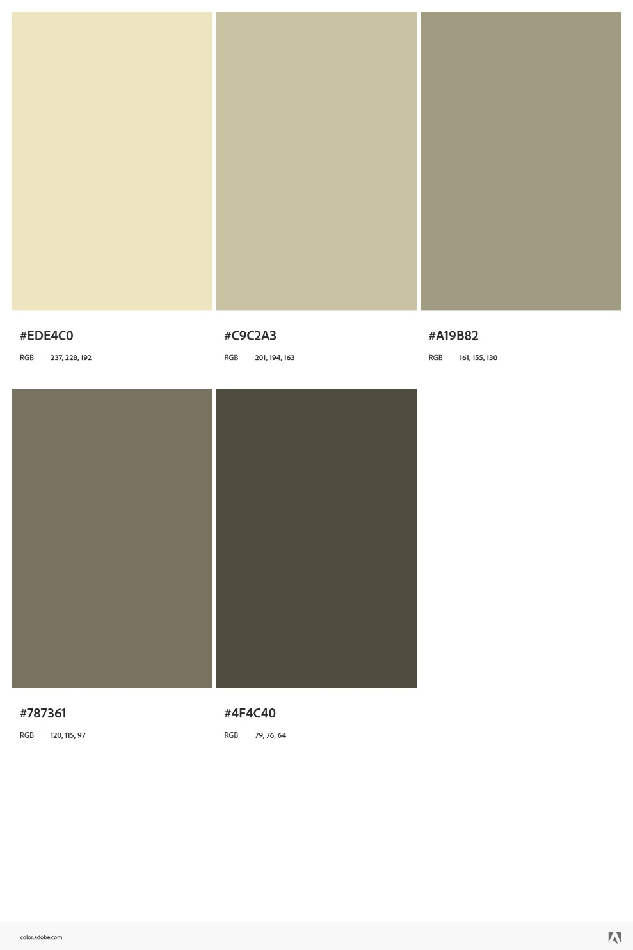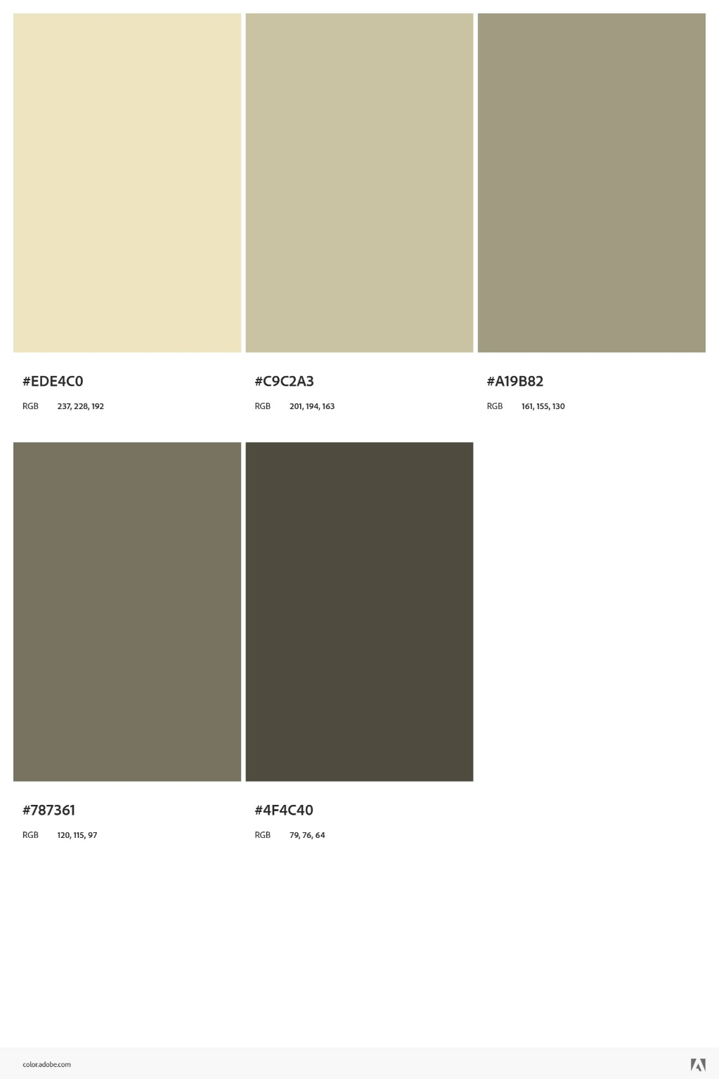Color palette by adobe color wheel cc
3. Minimum contrast accepted for accessibility 6.6:1
4. Front end development technologies: HTML,CSS,JS
5. Content management system: WordPress
6. Back end development technologies: PHP, Flask, Laravel
7. Metrics planning to use: convention rate, content rating by visitors, referrals, google analytics
8. HTML5 page structure (header)

<!DOCTYPE html>

<html lang="en">

<head>

<meta charset="UTF-8">

<meta name="viewport" content="width=device-width, initial-scale=1.0">

<title>PIckAfit</title>

<link rel="stylesheet" href="styles.css">

</head>

<body>

<!-- Header Section -->

<header>

<h1>PickAfit</h1>

<nav>

<ul>

<li><a href="#home">Home</a></li>

<li><a href="#wardrobe"> Wardrobe</a></li>

<li><a href="#outfits">Outfits</a></li>

<li><a href="#add ons">Add-ons</a></li>

<li><a href="#settings">Settings</a></li>

<li><a href="#sign in">Sign-in</a></li>

</ul>

</nav>

</header>

**Conclusion**

this assignment was an insightful journey about web design , I gained a highunderstanding of how websites have evolved from simple content pages to interactive, AI-driven platforms. For my website idea, I imagined a digital wardrobe that helps users pick outfits— based on different styles, occasions or vibes. This idea combines both functionality and fun. Looking back on this project now that I've finished it, I realized how much careful planning goes into building even a single website. Every single detail is crucial. Whether in designing an interface or building it. This assignment showed the importance of understanding the user, organizing content effectively, and designing with both aesthetics and functionality in mind. Overall, this assignment has given me a newfound interest for designing webs – specifically website design - excited to see where this knowledge takes me in the future.

# References

[1]

“Whering | The Social Wardrobe & Styling App – Whering,” *Whering*, 2024. https://app.whering.co.uk/login (accessed Nov. 03, 2024).

‌[1]

Adobe, “Adobe Color,” *Adobe.com*, 2021. https://color.adobe.com/create/color-contrast-analyzer

‌[1]

“Top Whering Alternatives, Competitors,” *Cbinsights.com*, 2021. https://www.cbinsights.com/company/whering-1/alternatives-competitors (accessed Nov. 03, 2024).

‌

[1]

QRFY, “QR Code Generator: Create your QR easily,” *QRFY*. https://qrfy.com/app/my-qr-codes

‌